**DRIVER CONTROLS**

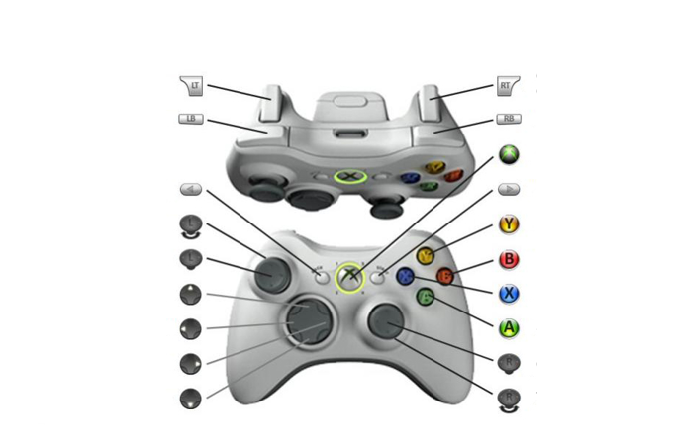

N/A

N/A

N/A

N/A

↕ Speed

N/A

N/A

↔ Turning

N/A

N/A

N/A

N/A

N/A

N/A

N/A

N/A

Shoot

Turn on Limelight

Auto Aim

**Operator Controls**



Spin up Shooter

Toggle Elevator Heights (Low/Middle/High)

↑ Manual Ball Path In  
↓ Manual Ball Path out  
↔ Control Wheel

Control Wheel: Spin to Color

N/A

Spit balls

Control Wheel:  
Spin 3x

Deploy/Retract

Intake

Deploy/Retract Control Wheel

N/A

N/A

N/A

N/A

↕ Elevator

N/A

Nom Nom

Winch/Climb

N/A

Shoot